标化考试内容及备考简介
相关网站链接
Official websites 各大考试官网:
- TOEFL: https://www.ets.org/toefl
- TOEFL中国: https://www.toefl.cn/
- IELTS: https://www.ielts.org/
- IELTS中国: https://www.chinaielts.org/
- GRE: https://www.ets.org/gre/
- GRE中国: http://gre-main.neea.cn/
- GMAT: https://www.mba.com/exams/gmat
- GMAT中国: https://gmat.neea.edu.cn/
Check destination acceptance查看接受的院校机构:
- TOEFL: https://www.ets.org/toefl/test-takers/ibt/where-to-study/destinations-search.html
- IELTS: https://www.ielts.org/about-ielts/who-accepts-ielts-scores
- GRE: https://www.ets.org/gre/revised_general/scores/send/aidi_fellowships
- GMAT: https://www.gmac.com/why-gmac/gmac-around-the-world/gmat-using-programs-schools
IELTS on Computer雅思机考:
- test centers in China: https://ielts.neea.cn/showTestCenters
Requirement on GRE/ GMAT (LSE's example) 示例：伦敦政经的GRE/GMAT要求
- LSE on GRE/ GMAT: https://www.lse.ac.uk/study-at-lse/Graduate/Prospective-students/Entry-requirements/GRE-and-GMAT
REAL test practice 真题资源搜索:
- TOEFL: search 'TOEFL TPO', find a version you like （可搜索‘托福TPO’，自行选择版本）.
- IELTS: buy Cambridge IELTS Official online （可购买‘剑桥雅思’题目）
- GRE: search ‘GRE机经’ （可搜索‘GRE机经’查找相关材料）
- GMAT: buy GMAT OG, or search 'GMAT OG' for e-book, and search 'GMAT机经' （可在官网购买‘GMAT OG’纸质或电子版，可自行搜索‘GMAT OG’电子版，可搜索‘GMAT机经’查找相关材料）

GRE成绩地图  GRE Score Requirement | TOEFL成绩地图  TOEFL Score Requirement
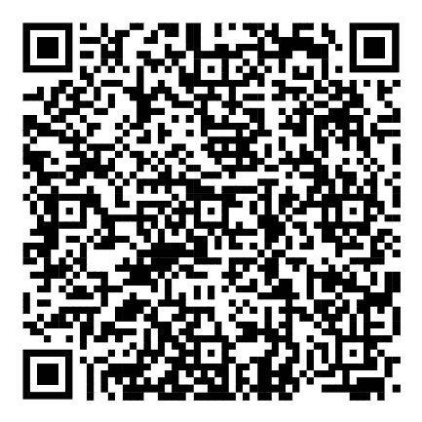 | 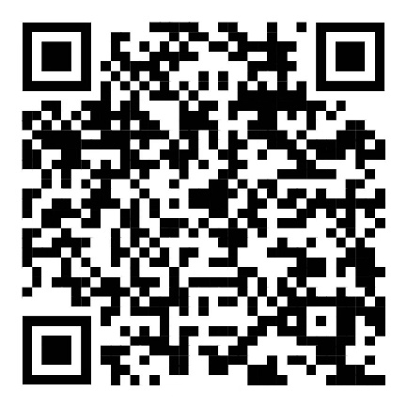

Checked and updated on 20250325.

